Escalating Conflict in the Red Sea Infrastructure Damage, Oil Market Disruptions, and Global Trade Implications

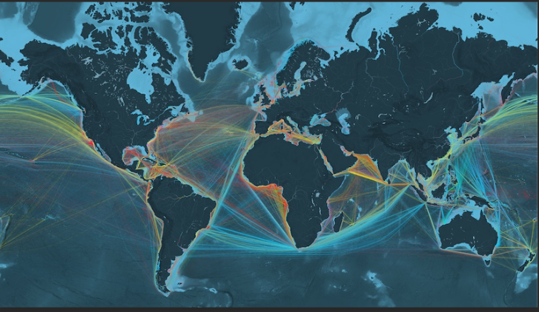

Report Authored By
Hydrocarbon Research Group

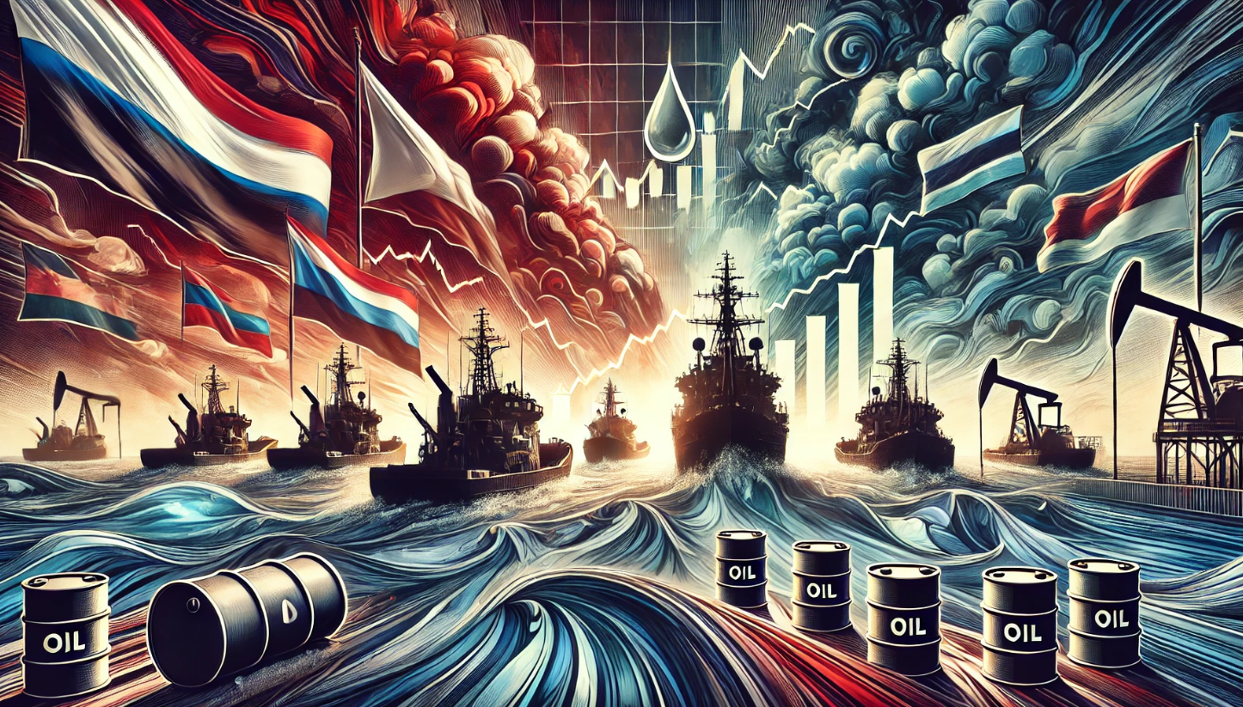

Summary
The escalating conflict between the Houthis and Israel has led to significant damage to critical infrastructure, disrupted shipping routes, and heightened concerns about global trade stability. Israeli airstrikes on Yemen's strategic port of Hodeidah targeted fuel storage facilities, cranes, and a power plant, resulting in reduced operational capacity and increased costs. These attacks have also caused oil contamination and impacted aid shipments. In response, international efforts have intensified to secure maritime routes, with rerouted shipping adding substantial fuel expenses and travel time. The conflict's broader implications include volatility in the oil market and increased global trade costs.

Israel-Palestine
The Israel-Palestine conflict continues to escalate with intensive Israeli military operations across Gaza and the West Bank. In Gaza, recent attacks in Khan Younis have resulted in significant casualties, with at least 70 Palestinians killed and over 200 injured. The IDF's 98th Division has launched a clearing operation to disrupt Hamas activities in the area. Israeli airstrikes have targeted various locations, including the Nuseirat refugee camp. In the West Bank, the Shin Bet uncovered a plot by Palestinian fighters to kidnap IDF soldiers and Israeli civilians,
further heightening tensions. The humanitarian situation in Gaza is dire, with reports of an imminent famine and devastating conditions for civilians. Thousands of Palestinians are being forced to flee the ongoing offensives, and the UN and human rights organizations have expressed grave concerns about the worsening crisis.
Regional tensions are also rising, with Yemen's Houthis targeting vessels in the Red and Mediterranean Seas, including oil tankers. Hezbollah in Lebanon continues to engage in cross-border conflicts with Israel, prompting Israeli strikes on Hezbollah targets in southern Lebanon. Despite international pressure and expected ceasefire talks, progress towards a resolution remains uncertain. The United States continues to play a significant role, supporting Israel while discussing efforts to mitigate the humanitarian crisis. The situation remains highly volatile, with increasing civilian casualties and a worsening humanitarian crisis in Gaza, highlighting the urgent need for a long-term solution to the conflict.
Houthis
The Houthis, are connected to the Israel-Palestine conflict due to their alignment with Iran and opposition to Israel and U.S. Their attacks on Israeli and allied shipping aim to support the Palestinian cause and show solidarity with Hamas. By leveraging their strategic position along the Red Sea, they disrupt international maritime traffic to pressure Israel and its allies and draw global attention to the conflict. The Houthis control a significant portion of Yemen's Red Sea coastline, estimated to be around 200 kilometers out of the approximately 440 kilometers of coastline. This control enables them to conduct attacks on commercial shipping and influence maritime traffic in the region. Their actions have significantly disrupted international trade routes, particularly affecting vessels traveling through the Suez Canal and The Bab el-Mandeb Strait. The Bab is a key chokepoint in the region. Crude volume moving through this strait was approximately 8.8 mb/d. These tensions have forced vessels to re-route and doing so has increased premiums and prices. Below is a graph that highlights the 127 attacks in the region.
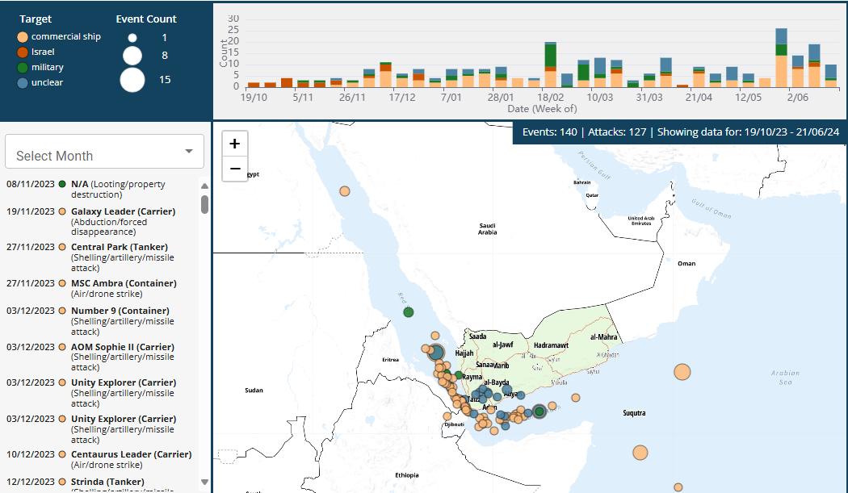
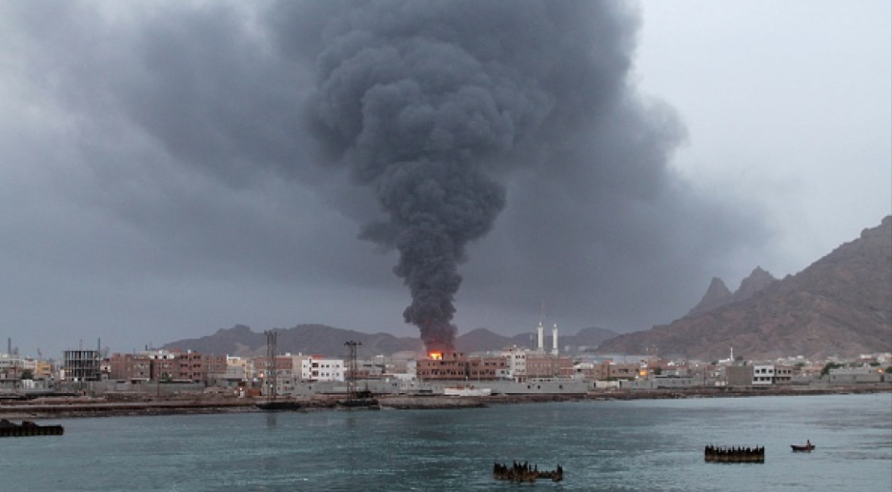

Recent Attacks
The recent Houthi rebel attacks has raised significant concerns about regional security. In a notable escalation, the Houthis launched a drone strike on Tel Aviv, marking the first such attack on the city. This strike resulted in one casualty and ten injuries, causing considerable alarm among Israeli residents.
In addition to this, the Houthis fired several missiles at the Israeli city of Eilat, which were intercepted by Israel's Arrow 3 missile defense system. These actions have not only heightened tensions in the Middle East but have also underscored the broader implications for global trade and security.
Simultaneously, the Houthis targeted oil tankers in the Red Sea, including the MT Chios Lion, a Liberia-flagged tanker carrying Russian oil to China, and the MT Bentley I, carrying Russian vegetable oil to China. The attacks were executed using unmanned surface vessels, causing damage to the tankers and further raising concerns about the security of shipping lanes in the Red Sea—a crucial route for global oil trade.
In response to these maritime threats, the US and European countries have increased naval patrols in the region to safeguard commercial vessels. These heightened security measures aim to ensure the safe passage of oil and other goods through the Red Sea, mitigating potential disruptions in global energy markets. The combined impact of these incidents underscores the vulnerabilities in both maritime transport routes and regional stability, prompting international efforts to enhance security and protect critical trade corridors.
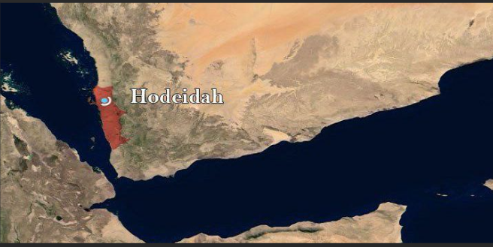

Israel Responds.
In retaliation for Houthi attacks, Israel conducted its first military strikes in Yemen, targeting the strategic port of Hodeidah. The airstrikes, aimed at disrupting Iranian arms shipments to the Houthis, resulted in six fatalities and numerous injuries, mainly among civilians. The conflict has significantly impacted the oil market by damaging the crucial Hodeidah port and disrupting Red Sea shipping routes, essential for global oil trade. In addition to oil storage the port handles a variety of imports, including raw and processed foodstuffs, machinery, metal goods, and consumer goods.
Damages and Impact
- Fuel Storage Facilities - Israeli airstrikes reduced the port's fuel storage capacity from 150,000 tonnes to 50,000 tonnes, destroying at least 33 oil storage tanks. This caused significant fires and thick black smoke for days.
- Cranes and Equipment: The strikes incapacitated several cranes, leaving at least five non-functional and impacting the port's cargo handling efficiency.
- Power Plant - A nearby power plant was targeted, causing electricity supply disruptions. Repairs are underway to restore power to the city.
- Oil Contamination - Tens of thousands of liters of oil ignited, leading to localized coastal contamination from wastewater and leaking fuel.
- Aid Shipments - The World Food Programme reported minor damage to an aid vessel and the destruction of 780,000 liters of fuel stock, necessitating new supplies to maintain operations.
Costs and Extended Travel Times
- Operational Costs - The destruction of fuel storage facilities and cranes will incur significant repair and replacement costs, with substantial economic implications due to the loss of storage capacity and equipment.
- Extended Travel Times - Due to damage and security concerns, shipping routes may need adjustment, leading to longer travel times and increased fuel consumption for vessels avoiding the Red Sea.
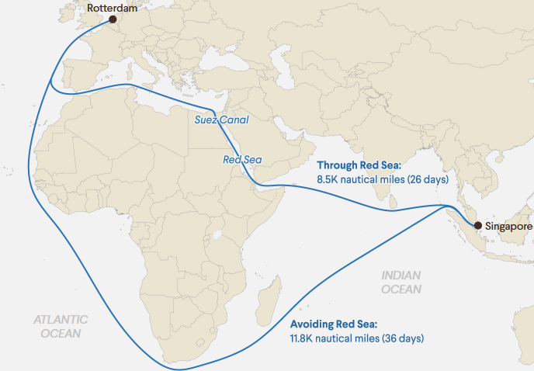
Mitigations & Re-Routes
The attacks by the Houthi’s on commercial vessels in the Red Sea has forced shipping companies to reroute their vessels around the Cape of Good Hope, leading to significant increases in costs and travel times. These disruptions have also caused higher volatility in the oil market, impacting global trade routes and operational expenses.
- Rerouting Costs -Additional fuel expenses per round trip can reach up to $1 million, with journey times extended by up to two weeks.
- Trade Volume Increase- The Cape of Good Hope saw an 80% increase in daily trade volume, reaching 8.7 million tons on January 2, 2024.
- Additional Costs- The longer route has led to higher fuel costs, extended transit times from 19 to 31 days, and insurance premiums for Red Sea transits have doubled, with some premiums rising by up to 250% for Israeli-linked vessels.

International Response
In response to the recent Houthi rebel attacks, the U.S. has spearheaded a multinational naval task force to protect commercial vessels in the Red Sea. This coalition, supported by the UK, Canada, France, and Italy, is part of a 39-nation partnership dedicated to ensuring maritime security through continuous patrols and surveillance. Additional warships have been deployed to intercept Houthi threats, while patrol and escort operations for commercial ships are bolstered by aircraft and drone surveillance.
To address the root causes of the conflict and diminish Houthi support, humanitarian aid is being provided, along with economic assistance aimed at stabilizing regional economies and rebuilding infrastructure. This comprehensive approach seeks to foster long-term stability in the region.
These heightened security measures are crucial for maintaining the safe passage of oil and other goods through the Red Sea, a vital corridor for global trade. The combined impact of these incidents has highlighted the vulnerabilities in both maritime transport routes and regional stability, prompting robust international efforts to enhance security and safeguard critical trade corridors.
By strengthening maritime security and addressing the underlying issues, the international community aims to mitigate potential disruptions in global energy markets and ensure the continued flow of essential commodities. The coordinated actions of the multinational naval task force underscore the importance of collaborative efforts in maintaining regional stability and protecting global trade routes.

Takeaway
The Houthi-Israel conflict is causing some serious logistical issues resulting in escalated tensions, delays costs. This regional instability has prompted a robust international response to mitigate the impact on global trade. The significant damage to the Hodeidah port and subsequent rerouting of vessels around the Cape of Good Hope have highlighted the economic and logistical challenges faced by shipping companies. These disruptions have led to increased operational costs, extended travel times, and higher insurance premiums, all of which contribute to the volatility of the global oil market.
The heightened security measures, including increased naval patrols and surveillance, are critical for maintaining the safe passage of goods through key maritime routes. The involvement of a multinational naval task force illustrates the importance of collaborative efforts in addressing these security challenges. Furthermore, the economic assistance and humanitarian aid provided to stabilize regional economies and rebuild infrastructure emphasize the need for a comprehensive approach to conflict resolution.
Overall, the situation calls for sustained international cooperation to not only secure maritime routes but also address the underlying causes of regional instability. This will help ensure the continued flow of essential commodities, mitigate disruptions in global supply chains, and promote long-term stability in the affected regions.

Sources
Kiln | Data Visualisation
Israel war on Gaza live: Israel blocks Palestinians from 80% of Strip: UN | Gaza News | Al Jazeera
IEA – International Energy Agency
Iran Update, July 22, 2024 | Institute for the Study of War (understandingwar.org)
Israel/Palestine | Country Page | World | Human Rights Watch (hrw.org)
2024 World Oil Transit Chokepoints (eia.gov)
Managing the new political risks in oil and gas - WTW (wtwco.com)
Houthi Attacks Causing More Damage in the Red Sea, Merchant Traffic Through Suez Canal Down More than 50% - USNI News
Gaza: Security Council adopts US resolution calling for ‘immediate, full and complete ceasefire’ | UN News
US military: Chinese-owned tanker hit by Houthi missile in Red Sea, 5 drones downed | The Times of Israel
YCO: Attacks in the Red Sea | Interactive Map - ACLED (acleddata.com)
Houthi Attacks Causing More Damage in the Red Sea, Merchant Traffic Through Suez Canal Down More than 50% - USNI News
How Houthi Attacks in the Red Sea Threaten Global Shipping | Council on Foreign Relations (cfr.org)
Vessel traffic in Cape of Good Hope sees significant spike in last 2 months (aa.com.tr)
Cargo vessel operators divert ships from Red Sea following Houthi attacks | Automotive Logistics
Mapping the Red Sea attacks by Yemen's Houthis (aljazeera.com)v
YCO: Attacks in the Red Sea | Interactive Map - ACLED (acleddata.com)
Everything to know about Israeli and Houthi attacks amid war on Gaza | Israel-Palestine conflict News | Al Jazeera
Israel shoots down a missile fired from Yemen hours after a deadly Israeli strike on Houthi rebels | AP News
Israel intercepts missile from Yemen after airstrikes on Houthi port - The Washington Post
Israel shoots down missile fired from Yemen after striking Houthis | Reuters
Hodeidah | Yemen, Port, Location, & Map | Britannica
Houthi Ship Attacks Are Affecting Red Sea Trade Routes | The Washington Institute
How have Red Sea attacks by Yemen’s Houthi fighters affected companies? | Israel-Palestine conflict News | Al Jazeera
How Houthi Attacks on Ships in Red Sea Affect Global Trade (voanews.com)
How Houthi Attacks Impact U.S. Consumers | The Heritage Foundation

